ERRORS

- near 2g lite mode rename it as low bandwidth and people will chose not wether they want low bandwidth or not
- near hardware dispatch remove the iot thing
- We are getting temperature based on drivers location from gps and weather app linked to it in backend
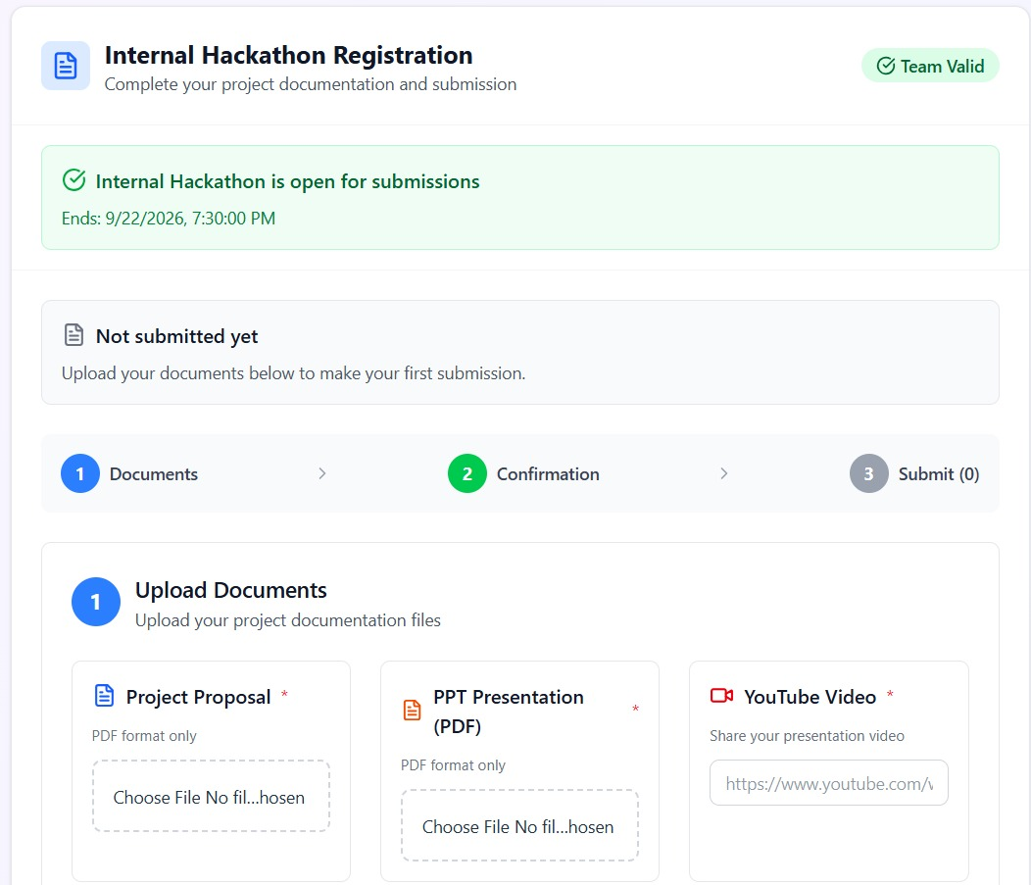

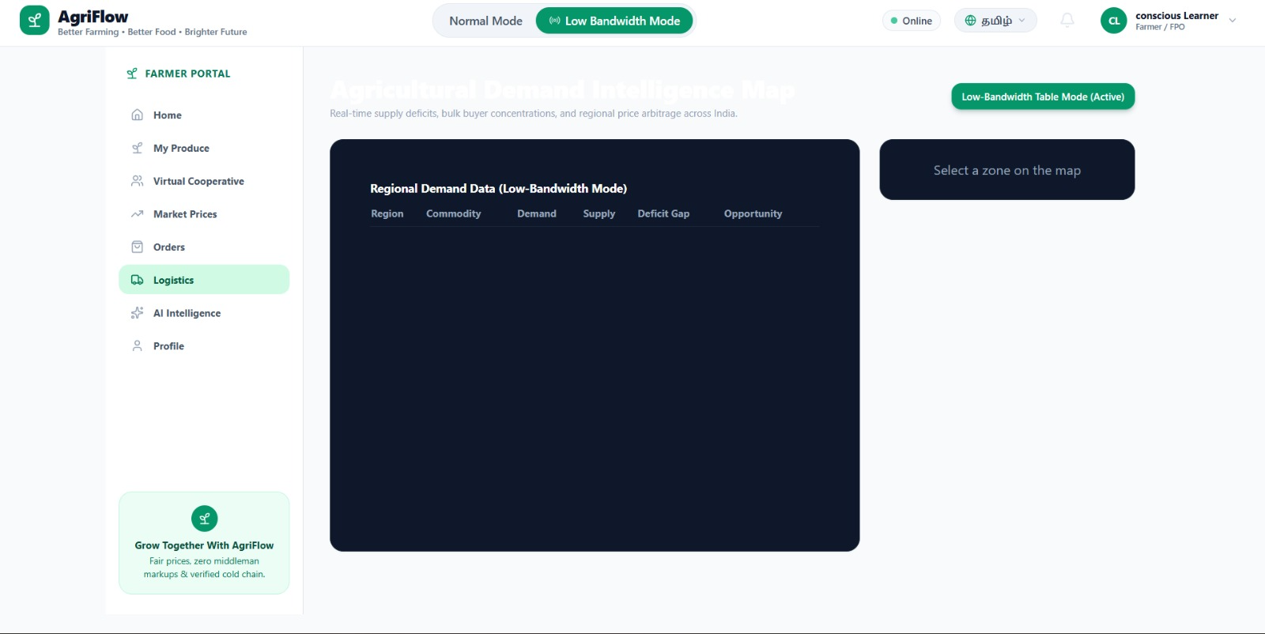
what should actually happen in this page....? does it work?

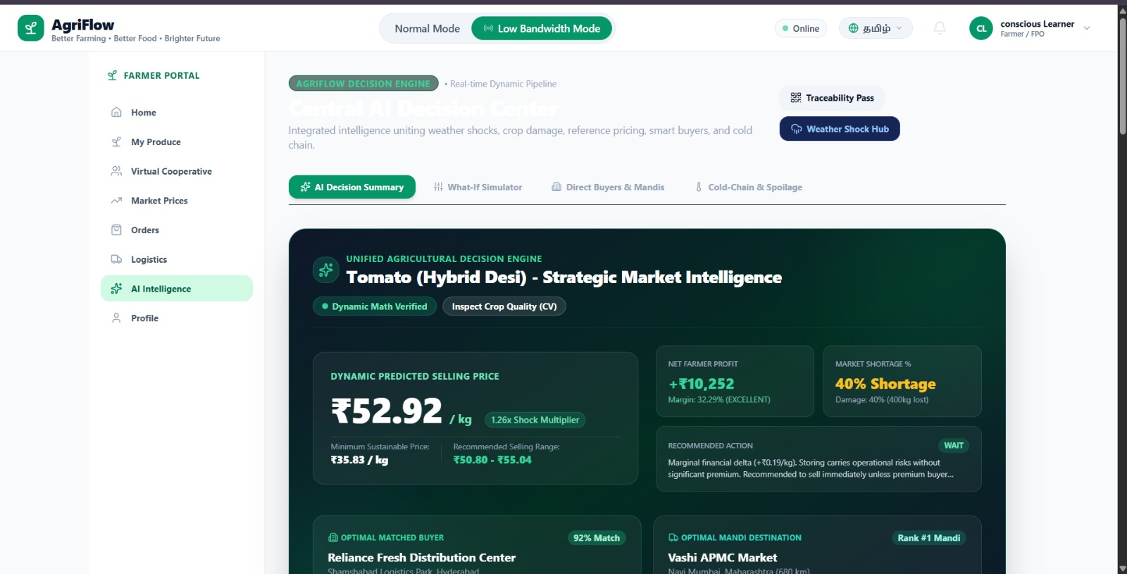
ai intelligence looks too complicated for a farmer.

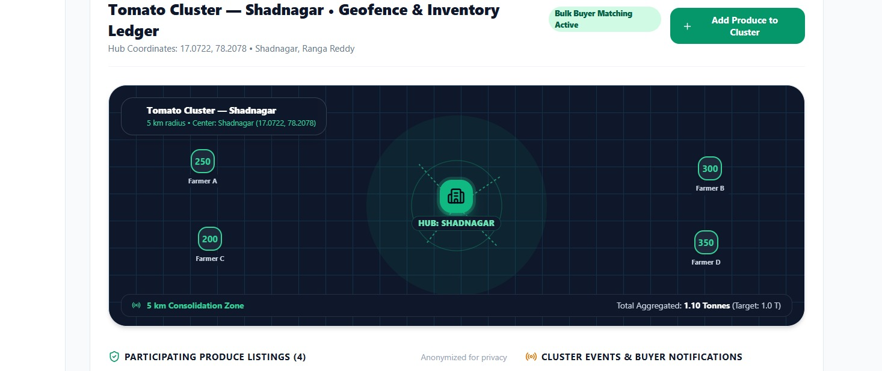

what is the use of this thing here and how does it work?
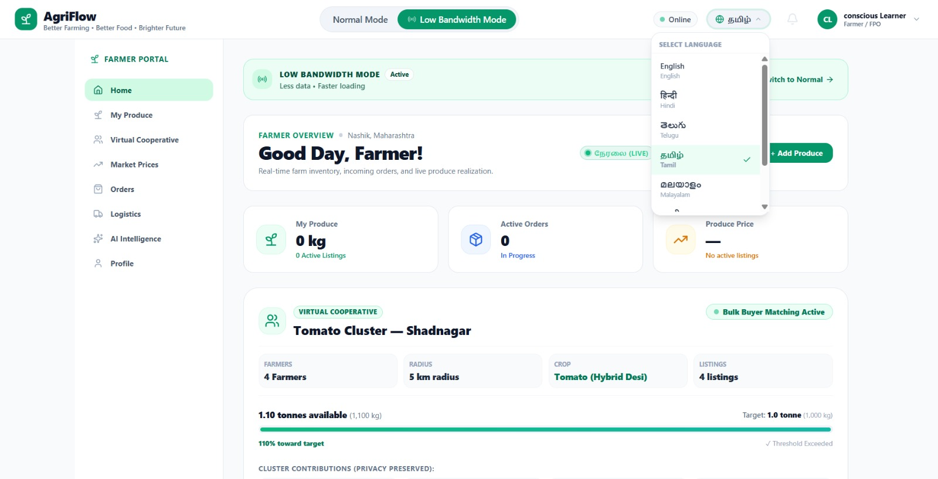
\
Lang error(I know this will solved in the end).
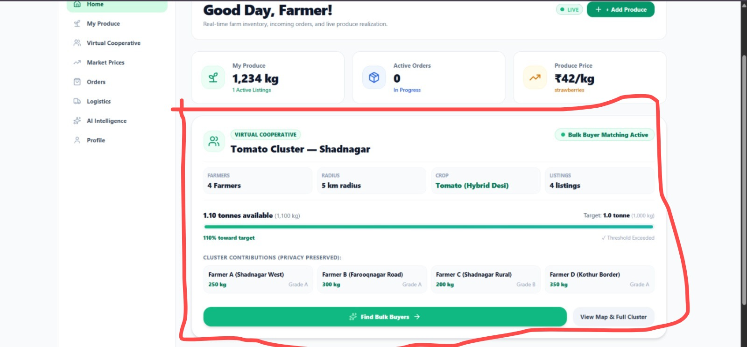

what is virtual cooperative, how does it work without farmers input?\
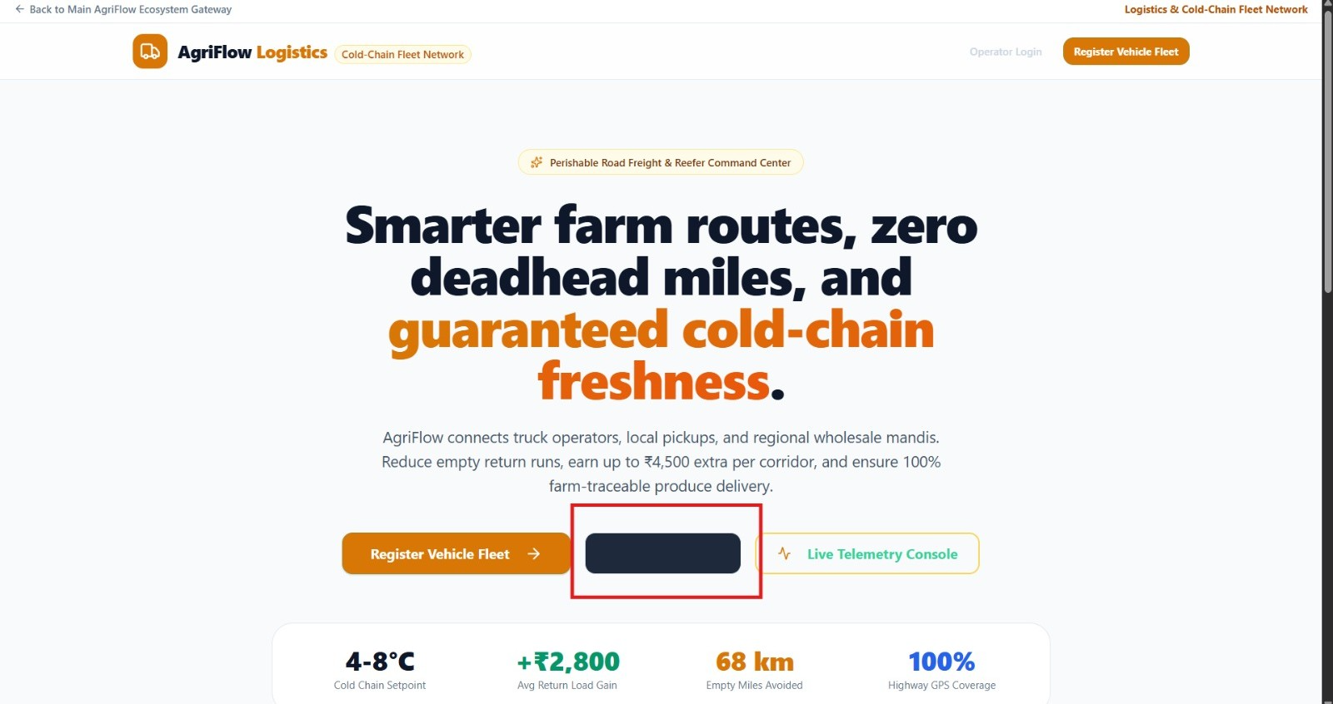

Black box thing is where it leads to login page....this black box and black text is overlapped and makes text invisible....

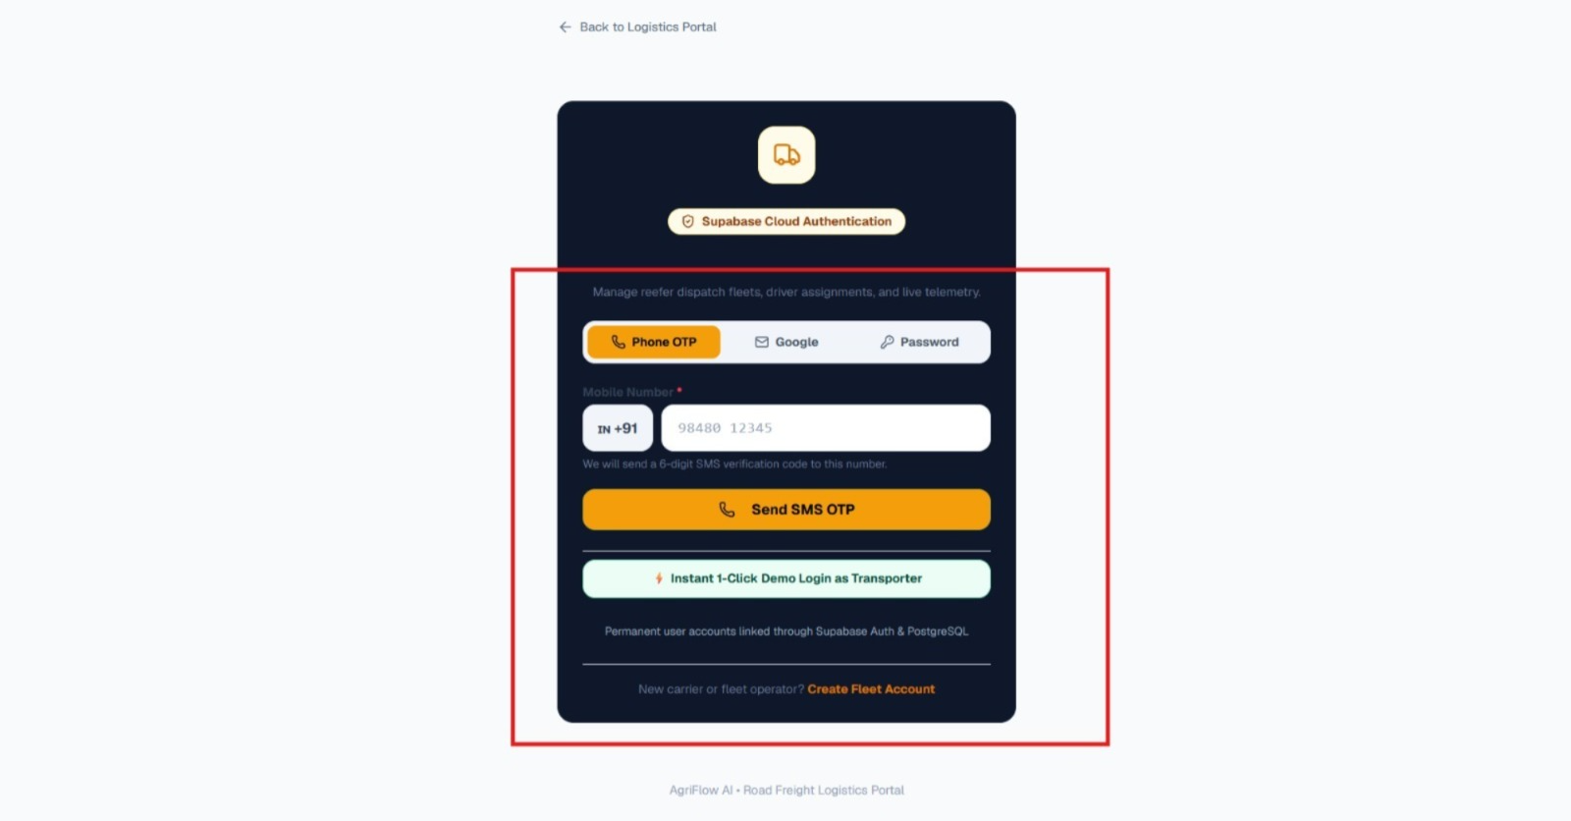

Phone number verification isnt working...
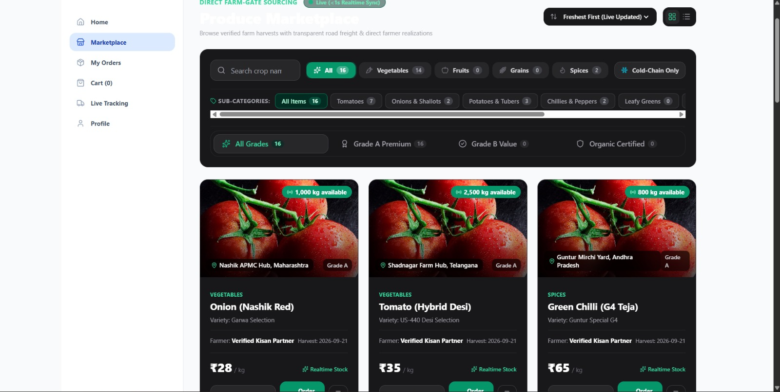\
Tomato looks fresh and tasty but kindly remove mock data.

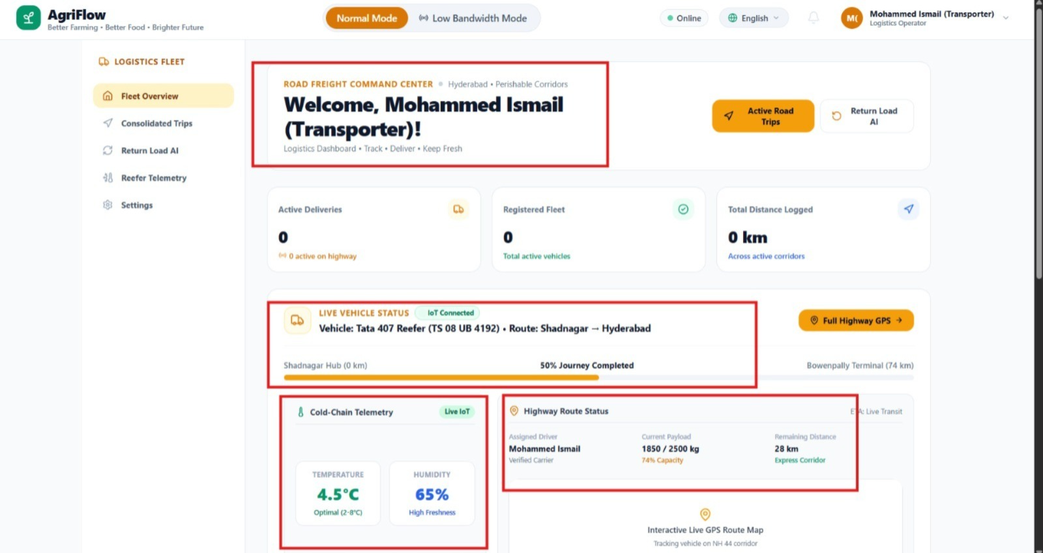

pre defined data
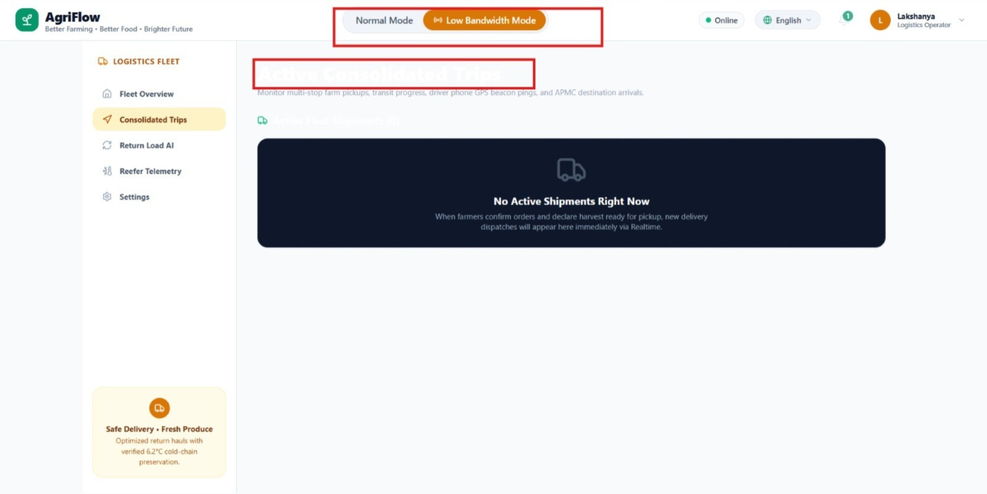

White text

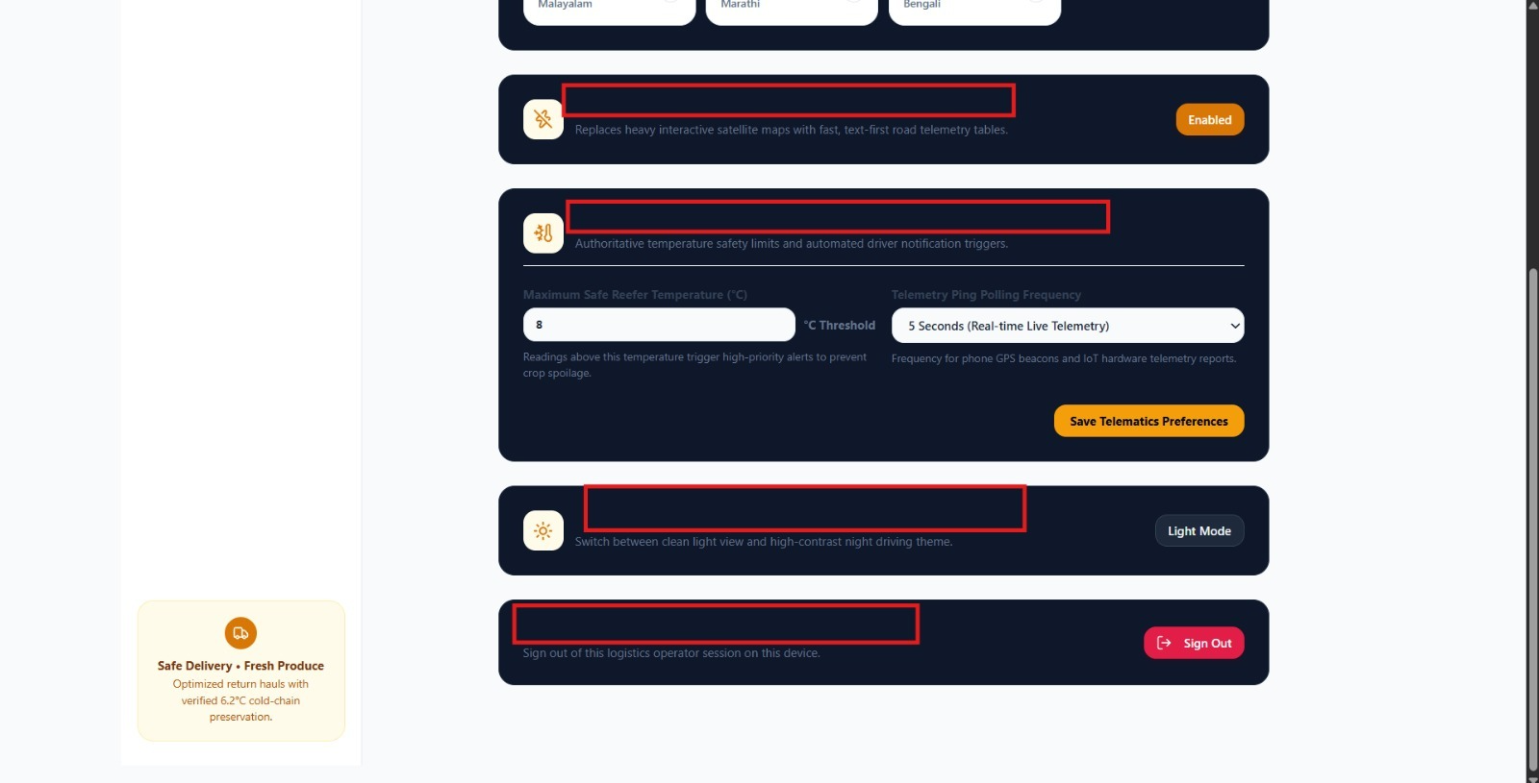

Black text overlap...

